IoT Based Smart Inhaler For Context-Aware Service Provisioning

Anindo Dey  Department of CSE  ULAB  anindo.dey.cse@ulab.edu.bd | Khendaker Afsanul Haque  Department of CSE  ULAB  khendaker.afsanul.cse@ulab.edu.bd | Al-Akhir Nayan  Department of CSE  EUB  asquiren@gmail.com | Muhammad Golam Kibria  Department of CSE  ULAB  golam.kibria@ulab.edu.bd

Abstract— The overall goal of the research work is to localize user needs and discover ways to implement electronics into the inhaler in order to solve the needs and improve the user experience and service provisioning. Planning a context-aware middleware may be a challenging issue because of particular characteristics of settings and gadgets such as the energetic nature of setting and asset confinement of gadgets. Moreover, the middleware ought to give an agreeable framework in which application designers seem effortlessly trade determining relevant data. To address these issues, an structural plan of a smart-inhaler for context-aware middleware is proposed in this paper that bolsters participation among application engineers. Our whole system is IoT based and our output will give an efficient system for the patients of Asthma. In this work, different types of sensors and the connections between the sensors and server are the main base of the system. Different types of sensors have been used for the working process and for the base system SOC (system on chip). Most importantly, this system should provide a good connection with the smartphone. As asthma patients consider inhaler to be their lifesaver, it needs to be efficient and user friendly. Considering all the possible options we have tried to deliver a smart product to those asthma patients.
Keywords— Health care, IoT, Context-aware middleware, Context-aware application, Sensors, Smartphone application.

Introduction
Asthma is a clinical condition that affects about 300 million individuals worldwide [1]. This is projected that by 2025 [2] there could be an extra 100 million individuals with asthma. Asthma accounts for about 1 of every 250 dies worldwide [3], while existing prevention, which naturally requires patient care, will avoid 80 percent of these death [4]. Further than 100 million people experience coughing and chest tightness in Bangladesh. Nevertheless, citizens are seeking unplanned care and consuming unscientific, natural and often dangerous goods in order to receive relief. Inhaled drug is as the main therapy for asthma had contributed to major changes in the management of asthma [5, 6]. Unchecked asthma, nevertheless, is still widespread and poses a significant burden on clinicians and society [7, 8]. IoT dependent context-aware intelligent inhaler program has now been introduced to concentrate on this issue and conventional inhaled medicine.
Context-awareness of the surrounding area of the patients has an important role in the IoT based service provisioning. Due to the changing condition of the surrounding area of the patients, the doze of the medication might be changed. Hence, an architecture has been described in this article which will collect the current data of the context using different physiological and contextual data, transmit them to server, analyze using machine learning mechanism and finally send the decision of the medication or advise through message.
Objective of the IoT based smart Inhaler is not only to remind a patient to inhale or to notify in case if patient forgets to bring with him, but also to compute the current status of the context of the patient and advise the amount of medication based on the context. Due to the variation of the context of the patient including the surrounding environment, weather, altitude sickness, etc. the amount of medicine to be inhaled by the same patient with similar physiological condition might be different. In the IoT based system, the smart Inhaler is connected to a patient through his smartphone application that will notify the patient to take puffs as per regular schedule or alarm to take immediate action.
The IoT based Smart Inhaler System provides several features as shown in Fig. 1.
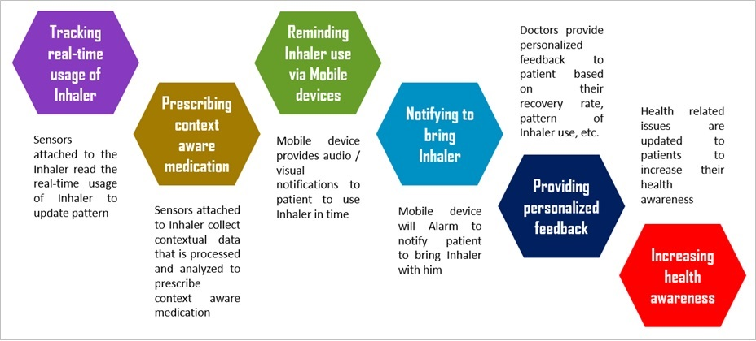
- Features of IoT based Smart Inhaler
The features include:
- Tracking real-time usage of Inhaler;
- Prescribing context aware medication;
- Reminding the patient by audio or visual notification to use Inhaler in time;
- Providing alarm to remind the patient to bring the Inhaler with him. The mobile device will alarm in case the patient moves out to a certain distance that is set by the patient. The app also allows the patient to search the lost Inhaler around him by tapping a Find button. In that case, the Inhaler will make a buzzer sound;
- Providing patient’s personalized medication based on their pattern of Inhaler usage recovery rate, physiological status, etc. Sensors attached to the Inhaler will collect and transmit data related to number of times and patterns of Inhaler use, physiological data that implies recovery rate by using the Inhaler, etc. A personalized health status of the patient or a personalized image of the course of the disease is predicted from the big data analysis, and modified personalized medication is prescribed to them through their mobile apps. Based on the personalized status and prediction, the system also warns the patient regarding any attack;
- Finally, since patients are connected through Mobile apps, they will be notified on several healthcare related information to increase their awareness.

IoT based Smart Inhaler System

Proposed System
An IoT based Smart Inhaler System has been proposed. The proposed system will not only smarter the traditional system of using Inhaler, but also increase the efficiency by accurate prediction of the availability, the amount of doze of medicine depending on the patients context. The proposed architecture is shown in Fig. 2.

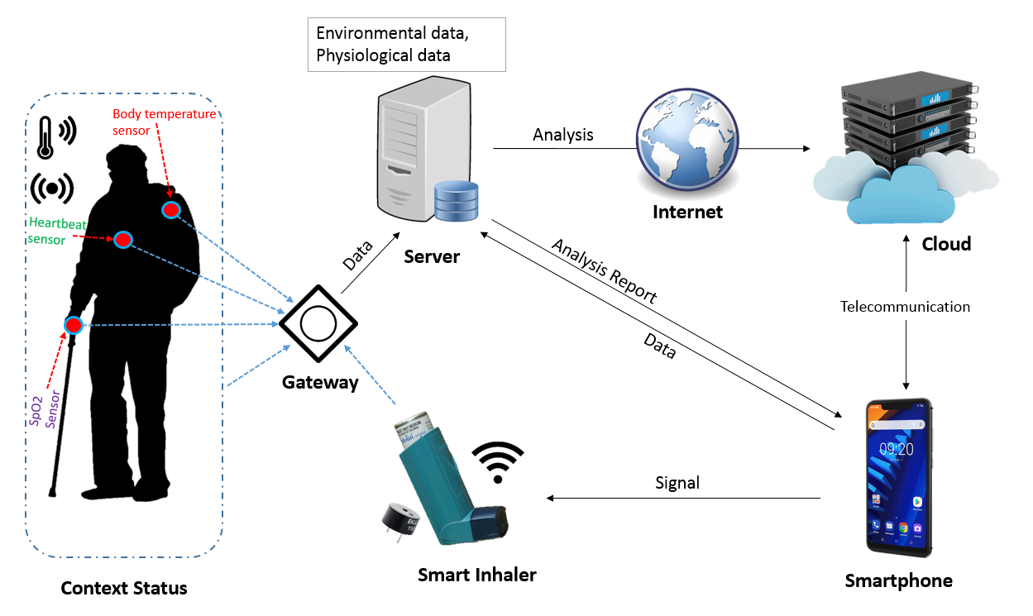
- Smart Inhaler

Implementation
The proposed system has been implemented to validate the efficiency of the system. The implementation architecture has been shown in Fig. 3.
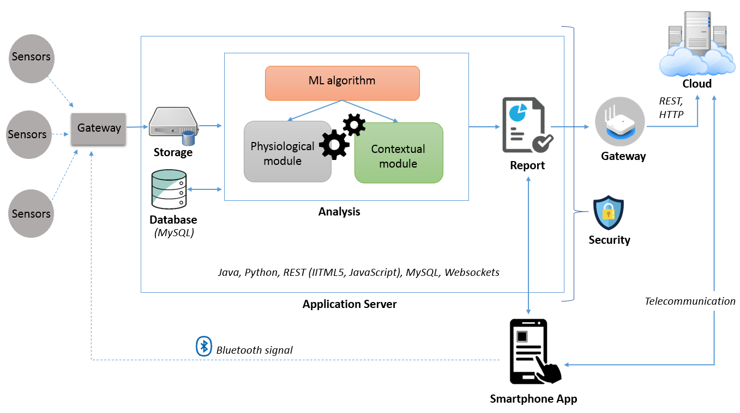
- Implementation of the system architecture
This architecture shows how the whole system performs. It shows that the sensors collects data. Basically those sensors are the main data collector which will be attached to both in the inhaler and user body. Those sensors will submit data and through getaway the data will be transmitted to the storage of the application server. Application server has database that stores data and use it for further analysis. After analysis of the data, there will be some particular decision regarding the decision that our system will get. Finally, after the data aggregation and decision making using ML algorithm, send it to the user’s app and to cloud server. This information will be the final outcome of the computation of those data. All this terms are described below more briefly.

Technological Concepts:
- Integration of various sensors (i.e. Multi-Pixel Gas Sensors SGP, Humidity sensor, Temperature sensor, Co2 Sensor, heartbeat sensor etc.) to gateway, Gathered for multi-sensor data purchase, autonomous of any specific application and module.
- Multi-sensor Information Relationship of Condition and the user’s physiological conditions in which the inhaler is used.
- Implementation of software and algorithms (here we are implementing machine learning algorithm), i.e. methods for computing contextual and physiological analysis from sensor data along with the previous MySQL and prolog database for better decision making, in application server and generate a result report.
- Sending the report to smartphone app as notify the user using Java and also cloud for storing that report in the server for further analysis through the network gateway using REST API and http.
- Sending digital signals to the gateway to accomplish any particular task such as sounding the buzzer attached to the inhaler (if needed) by pressing button on the pre-registered smartphone app which will be connected via Bluetooth with the inhaler.
- If application server is unable to sending report to smartphone app in a critical condition (pre-programed condition for worse emergency physiological and contextual situations) and the application server is connected to cloud service, then through telecommunication the report will send from cloud to the user’s registered sim card as form of massages.

Context-aware Middleware
Context-aware middleware is essentially combination of two elements in our analysis work, they are the Context Management System (CMS) [9], and the Knowledge and Notification System (ANS) [10]. The Context Control system facilitates the usage of context-aware software and resources to publish their contextual knowledge. The Knowledge and Messaging system is a rule-based facility that enables customer applications to apply to regulations that include meaning-based requirements and to provide notice when the framework has been established. The suggested unified middleware design of the links to client applications and information sources [11]. So in this case there will be a gateway and that is our context-aware middleware which will be connection bridge between ANS and CMS of the system. The repository includes a list, which has the responsibility for preserving a normal viewing of the domain context types. And we need to look at points as well, sign in and get out.

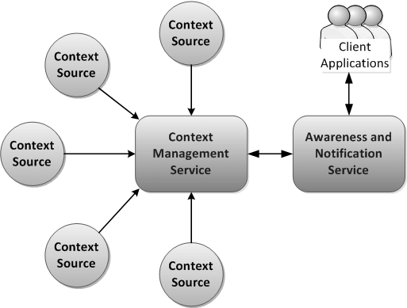
- Context-aware middleware architecture

Physiological Status Measurement Module
Sensors attached to a human body for reading oxygen level in blood, heart-beat rate, body temperature and then send these data to the server for further work. The following sensors have been used:
- SPO2 sensor (measures the oxygen saturation of a patient's blood)
ii. Heart beat sensor
iii. Body temperature sensor
The proposed system saves the data for providing better healthcare services. Data will come directly from the context source through context provider and saved in storage in the server, they will be analyzed and shown and notify to user by his registered smartphone application. For asthma patient oxygen level indication will make difference between usages of inhaler. Heart beat up down is directly connected with asthma, like a patient is having an attack, his/her heart beat rate will automatically rise. As the time and change in the heartbeat will be recorded in the storage, doctor can recall those data to have a close look of patient’s cardio logical conditions. Body temperature can differ in various situations. Hence, the proposed smart inhaler system considers this issue.

Environmental Context Measuring Module
Asthma trigger can change according to the change in environment around a patient. So considering this part, our works will be like: Sensors attached to human body for reading Environmental status such as humidity, temperature, amount of carbon dioxide and other gases mixing in the air and the data will be transmitted from the context source through context provider to the server for the analysis and further work. The following sensors have been used:

- Multi-Pixel Gas Sensors SGP
- Humidity sensor
- Temperature sensor
- CO2 Sensor
The sensors will collect data from the context, and the data will be analyzed to determine the environmental condition for the user. Like the level of carbon dioxide, Humidity, Temperature, oxygen etc. are very important to the level of taking medication of an Asthma patient. All of this data will be stored in the storage of the server and the doctor can suggest batter to the patient by seeing those data. Not only doctor, the user can also predict the future of his medication usage. As the level of all those factors will be directly connected to the usage of drug, user can have large/medium/small drug canister as per his need. And doctor as well as user will know for the next time, how much drug they are using in those situations.

Result and Discussion

Feature Data for Physiological Module
The training and testing set includes 3 features regarding physiological conditions.
- Feature data for Physiological module
FEATURE | DESCRIPTION
Oxygen level | Oxygen level (%) in user blood
Heart beat Rate | Heart beat rate (BPM) on user body
Body Temperature | Body temperature (°F) of user

In this case, this model uses 2 labels reflecting the classification of user:
1) Risk = risk condition for user.
2) Normal= normal condition for user.
Here are some measurements of Oxygen level and their classification for human Physiological Condition [12].
- Oxygen level in human body classification.
Oxygen level in blood (%) | Physiological Condition
95 – 100 | Normal
Less than 95 | Below normal
Here are some measurements of Heart Rate in human body and their classification for human Physiological Condition [13].
- Heart Rate in human body classification
Heart Rate (BPM) | Physiological Condition
60 -100 | Normal
100 < | Raising
190 | Maximum
The average body temperature is generally accepted as 98.6 °F (37 °C). Here are some measurements of Body temperature in human body and their classification for human Physiological Condition [14].
- Body temperature in human body classification
Body temperature (°F) | Physiological Condition
97.7 – 99.5 °F | Normal
99.5 or 100.9 °F < | Fever
95.0 °F > | Hypothermia

The training data for the Naive Bayes algorithm for the Physiological module is listed in Table V.

- Training data for Naive Bayes classifier (Physiological module)
 | Oxy_level | H_Rate | B_Temp | Level
1 | 98 | 65 | 98.5 | Normal
2 | 92 | 60 | 97.7 | Risk
3 | 98 | 150 | 99 | Risk
4 | 95 | 100 | 98 | Normal
5 | 95 | 98 | 99.5 | Normal
6 | 97 | 66 | 98.4 | Normal
7 | 89 | 52 | 94.2 | Risk
8 | 96 | 85 | 97.6 | Normal
9 | 95 | 62 | 98.1 | Normal
10 | 99.1 | 70 | 97.9 | Normal
11 | 100 | 60 | 99.7 | Normal
12 | 90 | 65 | 95.2 | Risk
.
.
.
1015 | 97.1 | 68 | 97.9 | Normal
1016 | 95 | 190 | 103.6 | Risk

The data continuously coming for physiological condition measurement sensors will be use for physiological condition measurement reading of user body. Now these data will be send to Naive Bayes classifier to test them. The data would be unleveled data. The classifier will level these data. The non-classify data would be like these:
- Test data for Naive Bayes classifier (Physiological module)
 | Oxy_level | H_Rate | B_Temp | Level
1 | 95 | 64 | 99.2 | ?
2 | 91 | 85 | 96.7 | ?
3 | 98 | 150 | 99 | ?
4 | 95 | 106 | 98 | ?

Feature data for contextual module
The training and testing set includes 3 features regarding contextual conditions.
- Feature data for contextual module
Feature | Description
Temperature (°F) | Temperature in the user context
Humidity (%) | Humidity in the user context
Air quality (mg/m³)¹³ | Quality of gas mixing in the air of user’s context

In this case, this model uses 2 labels reflecting the classification of user:
1) Risk = risk condition for user.
2) Normal= normal condition for user.
Researchers found that a room temperature of about 71 ° F (21.6 ° C) did not cause symptoms of asthma, but at 120 ° F (48.8 ° C) breathing in super-hot air did. And also try to remain indoors when the temperature drops very low, particularly if it is below 10 ° F (-12.2 ° C) to avoid asthma attacks [15].
- Temperature in the context classification
Temperature (°F) | Physiological Condition
10 – 100 | Normal
greater than 100 | Risk
Less than 10 | Risk
People usually find the most comfortable relative humidity between 30 and 60 percent, with guidelines for maintaining relative humidity indoors between 30 and 50 percent where possible. Higher humidity levels in the home provide an atmosphere for two excessive asthma and allergy causes [15].
- Humidity in the context classification
Humidity (%) | Physiological Condition
31 -50 | Normal
greater than 50 | Risk
Less than 31 | Risk
Breathe comfortably with the Multi-Pixel Gas Sensor SGP30 which is a fully integrated MOX gas sensor. To offer more accurate air quality signals, the SGP integrates several metal-oxide sensing elements on one chip. It returns a reading of Total Volatile Organic Compound (TVOC), and a reading of carbon dioxide (eCO2) equivalent [16].
- Humidity in the context classification
TVOC (mg/m³)¹³ | Air quality
Less than 0.3 | Very good
1.0 – 3.0 | Good
Greater then 3.0 | Poor

The training data for the Naive Bayes algorithm for the contextual module is listed in Table XI.
- Training data for Naive Bayes classifier (contextual module)
 | Temp | Humi | Air_q | Level
1 | 10 | 35 | 0.8 | Normal
2 | 25 | 43 | 1.2 | Normal
3 | 103 | 55 | 3.5 | Risk
4 | 36 | 40 | 1.9 | Normal
5 | 36 | 42 | 3.5 | Risk
6 | 9 | 29 | 0.9 | Risk
7 | 5 | 27 | 0.8 | Risk
8 | 57 | 43 | 2.7 | Normal
9 | 99 | 50 | 3.0 | Normal
10 | 87 | 49 | 2.4 | Normal
11 | 44 | 35 | 1.9 | Normal
12 | 25 | 46 | 0.3 | Risk
.
.
.
1015 | 40 | 41 | 2.8 | Normal
1016 | 68 | 37 | 1.2 | Normal

The data continuously coming for contextual condition measurement sensors will be use for contextual condition measurement reading of user context. Now these data will be send to Naive Bayes classifier to test them. The data would be unleveled data. The classifier will level these data.
- Test data for Naive Bayes classifier (contextual module)
 | Temp | Humi | Air_q | Level
1 | 25 | 32 | 3.0 | ?
2 | 101 | 50 | 1.9 | ?
3 | 76 | 39 | 2.5 | ?
4 | 54 | 42 | 0.9 | ?

Smartphone Application for Notification
An android Application has been developed that notifies at the time the user smartphone is connected to inhaler as well as at the time the smartphone is out of range. Due to the Bluetooth connection, the smartphone application provides notification in the case the smartphone takes away approximately 10 meters from the Inhaler.
In this research work, the application is connected to the inhaler means, serial data is passing from the Bluetooth low Energy (BLE) module to the smartphone app. When these serial data passing will stop that means the app is disconnected from the Bluetooth module or out of range of Bluetooth, then the app give disconnected notification to the user to not to forget to take inhaler. For the time being, this research work is done without BLE module which would be attached to the inhaler, but the experiment is done with a Laptop and the app by data passing between them which is same as data passing between BLE device and the app.
In this research, a Laptop is considered as a Smart Inhaler. The app gives notification when Bluetooth is connected and disconnected based on data transfer between the Laptop and the smartphone. The notification shows connected at the time when any data such as an image or music is shared, and the app shows disconnected right after the data transfer is finished. Considering the Laptop, when the app is out of range of Bluetooth connection with the Laptop, the Laptop does not notify disconnection notification to the user smartphone, this is because, once the smartphone is paired with the Laptop means it is paired permanently and remains paired until the history is removed. But the app works with BLE module properly.

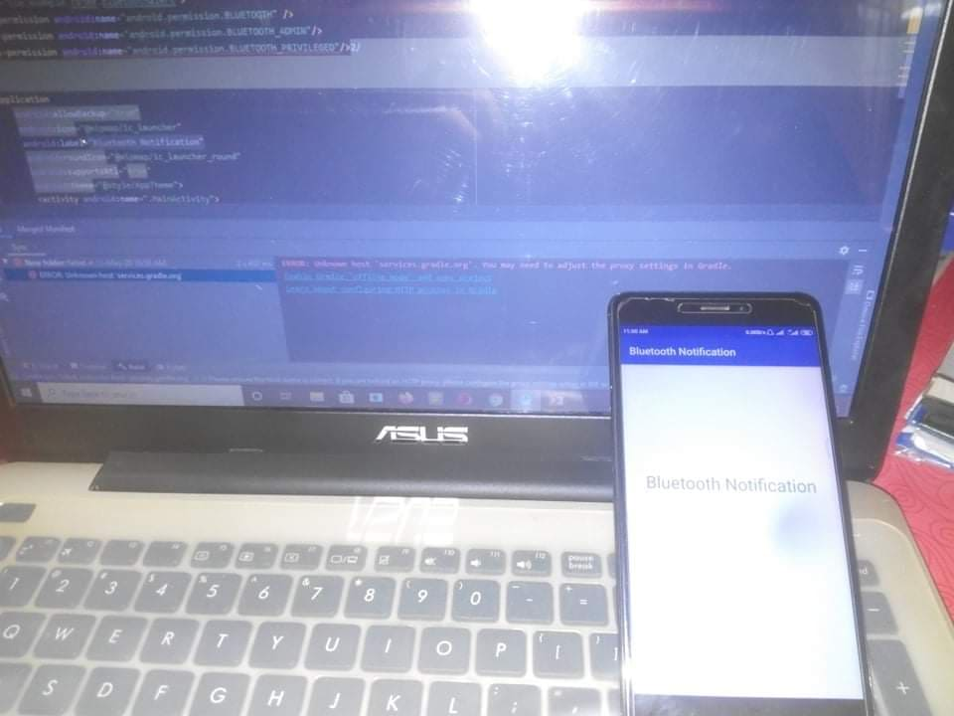
- Application connected with laptop via Bluetooth
The main purpose of the smartphone application is to provide notification in case the user forgets the smart inhaler to carry with. A notification is provided the notification bar. The app has been developed using Bluetooth Adapter API of Android development and tested in the research work. At the time the application is connected with the Bluetooth of the Laptop, the app will show notification as Connected because of the data transfer is being happened between them. The app will show notification as Disconnected because of the interruption of data transfer between them.
At the time, the app is connected with the Bluetooth of the Laptop, the app notifies Connected as the data transfer is being started. As long as the data transfer is taken place, the app will show connected that represents connection between the Laptop and smartphone app. Fig. 6 shows the connected status of the smartphone app.

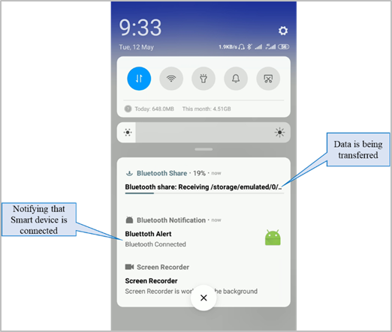
- Connected State of Notification
At the time, data transfer is completed from the Laptop to the smartphone, the smartphone app will automatically notify Disconnected. This state implies that if smart Inhaler lost network connection from the smartphone, the smartphone app will automatically notify the user. After successfully completion of data transfer from the laptop to the smartphone, the smartphone app notifies Disconnected as shown in Fig. 7.

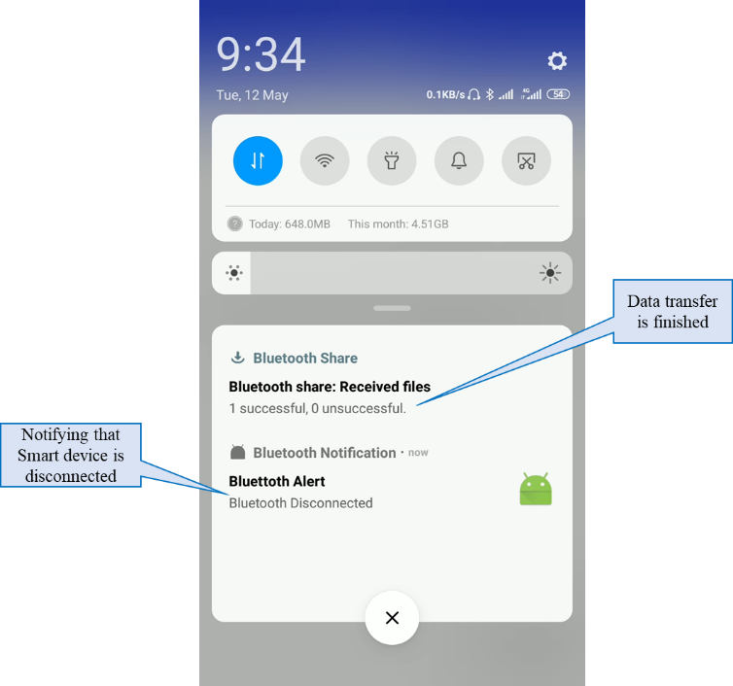
- Disconnected State of Notification

Conclusion
The function of health care is to include patients in vital details and to encourage patients to accept responsibility for their condition and cure the disease. So the target for Smart Inhaler is not different, the key goal is for the individual to continue to survive as symptom-free as possible while getting as much influence as possible over asthma. Those users who will use this smart inhaler will lead a much efficient and better life. Furthermore, it is vital for the individual to learn to identify early indicators of improvement and allow appropriate risk evaluations and to recognize when to adjust the drug items, if exacerbation happens. As those people will come to know more about their asthma attack symptoms, they will be much careful and alert when our smartphone app will notify them about the changing condition of their body as well as the environment around them.
Till now, the asthma cannot be cured completely, but the smart inhaler system will give them the ability to recognize those changes in their asthma behavior and act smartly prevent the next attack. We always seek to accomplish this sort of tool in our situation, which would offer asthma patients the ability to have more smart control over their everyday inhaler and self-care and we have a solution with this smart inhaler system.
We also expanded our expertise of user-centered architecture and aim for better user experience, so that the user of the smart inhalers system can have great comfort when using this device. Besides the comfort, the cost of medical admission will be saved, as there will be less medical admission.
In a word, making those asthma patients more comfortable in their daily life is our main goal from this research work. They can’t cure their asthma completely, but they will be leading a much efficient life by using our Smart Inhaler. The main focus of the research work wasn’t only the user of this device, but also doctors, who will see the statistics of the usages, changes in the medication of the user, ups & downs in their health. All of this indicator will give much better medication option for the user. As the doctor will analyze the statistics, they will give better suggestions to the users.
We hope that all of our effort would result in less emergency room admissions, Parents having less time off to take their children to clinics, and stronger and quicker commitment than the conventional approach by allowing the patient more power of their everyday inhaler and knowledge of their asthma. We believe that, coupled with the opportunity to gather useful scientific results to enhance long-term asthma studies, would be of tremendous value to a community with an increasing population of asthma. Most of all giving a life, where they can worry less and enjoy more of their life. Because they will be in control most of the time, by overlooking their physical, environment & medication change in their daily life.
Due to the lacking of hardware devices and all the functionalities yet to be implemented, a prototype has been implemented. It is our high priority to implement all the essential functionalities soon to develop a real system.

Acknowledgment
This research work has been supported by the IoT Lab, a state-of-art specialized research facility of its kind situated at ULAB, implemented and supported by the Bangladesh Hi-Tech Park Authority of ICT Division.

References
- U. K. Barua, S. K. Saha, D. K. Ghosh and M. M. K. Ruble, “Epidemiological Study on Bronchial Asthma at Shaheed Suhrawardy Medical College Hospital, Dhaka”, J Shaheed Suhrawardy Med Coll, vol.5(2), December 2013.
- British Thoracic Society, Scottish Intercollegiate Guidelines Network, “British guideline on the management of asthma.” Thorax, vol. 63(4), pp. iv1–iv121.
- E. D. Bateman et al., “Global strategy for asthma management and prevention: GINA executive summary.” The European Respiratory Journal, vol. 31, pp. 143–178, January 2008.
- S. P. Peters, G. Ferguson, Y. Deniz and C. Reisner, “Uncontrolled asthma: a review of the prevalence, disease burden and options for treatment.” The European Respiratory Journal, vol. 100, pp. 1139–1151, May 2006.
- D. Delen, C. Fuller, C. McCann, D. Ray, “Analysis of healthcare coverage: a data mining approach.” Expert Systems with Applications, vol. 36(2), pp. 995–1003, March 2009.
- F. Ramparany, R. Poortinga, M. Stikic, J. Schmalenströer, T. Prante, “An open Context Management Infrastructure.” 3rd IET International Conference on Intelligent Environments 2007 – IE07, Ulm, Germany, September 2007.
- L. O. B. D. S. Santos et al., “A Service Architecture for Context Awareness and Reaction Provisioning.” 2nd Modeling, Design, and Analysis for Service-Oriented Architecture Workshop (MDA4SOA 2007), Salt Lake City, USA, July 2007.
- L. O. B. D. S. Santos, R. P. V. Wijnen and P. Vink “A service-oriented middleware for context-aware applications.” Natural Language Engineering. pp. 37-42, November 2007.
- H. V. Nejad, K. Zamanifar and N. Nematbakhsh, “Context-Aware Middleware Architecture for Smart Home Environment.” International Journal of Smart Home, vol. 7(1), January 2012.
- I. F. Darwin, “Android Cookbook: Problems and Solutions for Android Developers.” 2nd ed., 2017.
- R. Sharma, “Top 15 Sensor Types Being Used Most by IoT Application Development Companies.” [Online] Available at: https://www.finoit.com/blog/top-15-sensor-types-used-iot/ [Accessed: April 19, 2020].
- B. Gholipour, “What Is a Normal Heart Rate?” [Online] Available at: https://www.livescience.com/42081-normal-heart-rate.html [Accessed April 28, 2020]
- MedlinePlus.gov, “Body temperature norms.” [Online] Available at: https://medlineplus.gov/ency/article/001982.htm [Last Accessed: April 28, 2020]
- iqair.com, “Temperature, humidity and your asthma.” [Online] Available at: https://www.iqair.com/ca/blog/asthma-allergies/humidity-induced-asthma-symptoms [Last Accessed: April 28, 2020]
- O. J. Adebayo et al., “Indoor Air Quality Level of Total Volatile Organic Compounds (Tvocs) in a University Offices.” International Journal of Civil Engineering and Technology, vol. 9(11), pp. 2872-2882, November 2018.
- University of Roachester Medical Center, [Online] Available at: https://www.urmc.rochester.edu/pulmonary/patient-care/asthma-obstructive-lung-disease/asthma-general-information.aspx [Last Accessed: April 19, 2020].

